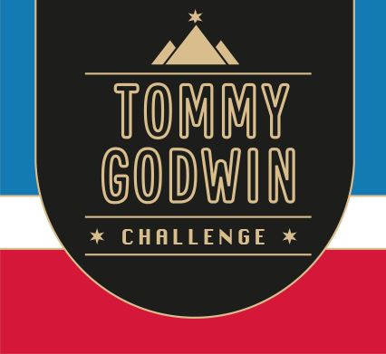

Certificate of Achievement

This Acknowledges That
Your Name

Has Successfully Completed
2023 – France cycle
1,729  kms | 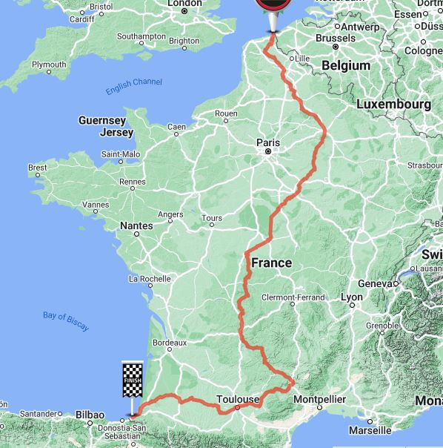 | 