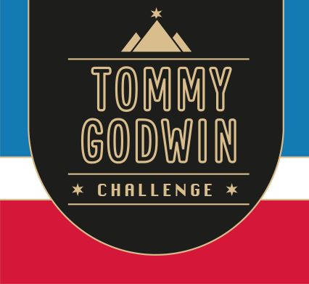

Certificate of Achievement

This Acknowledges That
Your Name

Has Successfully Completed
2022 – Scotland walk/run
516  miles | 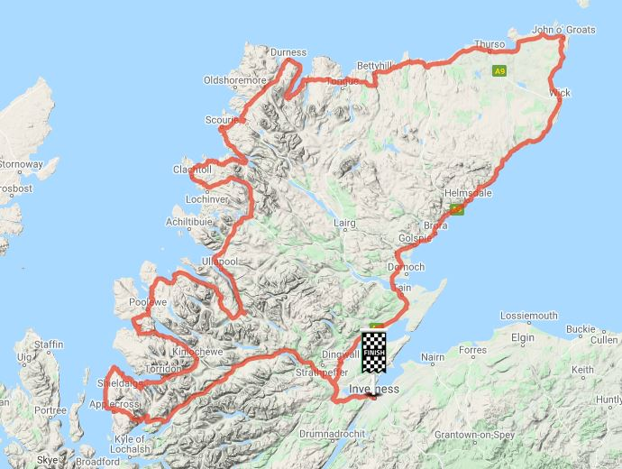 | 