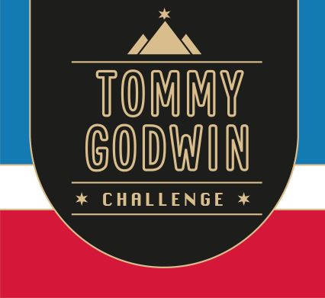

Certificate of Achievement

This Acknowledges That
Your Name

Has Successfully Completed
2023 – France walk/run
488  kms | 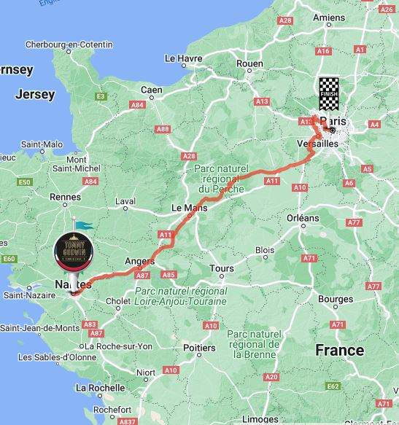 | 