Certificate of Achievement

This Acknowledges That
Your Name

Has Successfully Completed
2022 – Wales cycle
500  miles | 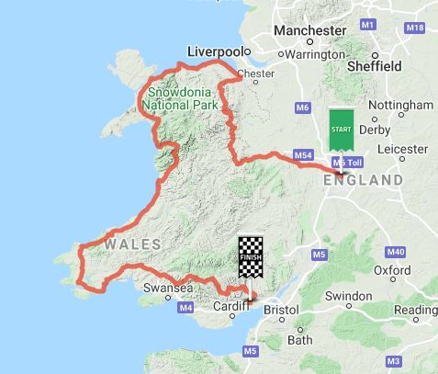 | 